# 1. Create a html table with columns for country name, national sport, national flower, national animal, national tree.  There should be five countries as rows in the table.

# <html lang="en">

# <tr>

# <td>New Zealand</td>

# <td>Rugby Union</td>

# <td>Kowhai</td>

# <td>Kiwis</td>

# <td>Silver-fern</td>

# </tr>

# <tr>

# <td>USA</td>

# <td>Baseball</td>

# <td>Rose</td>

# <td>Bald eagle</td>

# <td>Oak</td>

# </tr>

# </table>

# <br /><br /><br />

# </body>

# </html>

# <head>

# <title>TABLE EXERCISES</title>

# <style>

# table {

# text-align: center;

# border: 1px solid;

# padding: 10px;

# border-collapse: collapse;

# }

# table tr,table th,table td {

# border: 1px solid;

# padding: 5px;

# }

# </style>

# </head>

# <body>

# <table>

# <tr>

# <th>COUNTRY NAME</th>

# <th>NATIONAL SPORT</th>

# <th>NATIONAL FLOWER</th>

# <th>NAITONAL BIRD</th>

# <th>NAITONAL TREE</th>

# </tr>

# <tr>

# <td>India</td>

# <td>Hockey</td>

# <td>Lotus</td>

# <td>Peacock</td>

# <td>Banyan</td>

# </tr>

# <tr>

# <td>Australia</td>

# <td>Cricket</td>

# <td>Acacias</td>

# <td>emu</td>

# <td>Golden wattle</td>

# </tr>

# <tr>

# <td>Japan</td>

# <td>Sumo wrestling</td>

# <td>Chrysanthemum</td>

# <td>Green pheasant</td>

# <td>Japanese Red Cedar Sugi</td>

# </tr>

**2.** Create a Html table to display your class time table.

<html lang="en">

<th>Wednesday</th>

<td>Computer Security</td>

<td>Data Structure Using C</td>

<td>-</td>

<td>Enterpreneurship Development</td>

<td>-</td>

</tr>

<tr>

<th>Thursday</th>

<td>Computer Security</td>

<td>Internet & Web Designing</td>

<td>-</td>

<td>-</td>

<td>Ecommerce</td>

</tr>

<tr>

<th>Friday</th>

<td>Internet & Web Designing</td>

<td>Enterpreneurship Development</td>

<td>-</td>

<td>Ecommerce</td>

<td>-</td>

</tr>

</table>

<br /><br /><br />

</body>

</html>

<head>

<title>TABLE EXERCISES</title>

<style>

table {

text-align: center;

border: 1px solid;

padding: 10px;

border-collapse: collapse;

}

table tr,

table th,

table td {

border: 1px solid;

padding: 5px;

}

</style>

</head>

<body>

<table>

<tr>

<th>Days/Time</th>

<th>9.00am-10.00am</th>

<th>10.30am-11.30am</th>

<th>12.00pm-1.00pm</th>

<th>2.00pm-3.00pm</th>

<th>3.15pm-4.15pm</th>

</tr>

<tr>

<th>Monday</th>

<td>Computer Security</td>

<td>Data Structure Using C</td>

<td>Indusrial Training</td>

<td>Enterpreneurship Development</td>

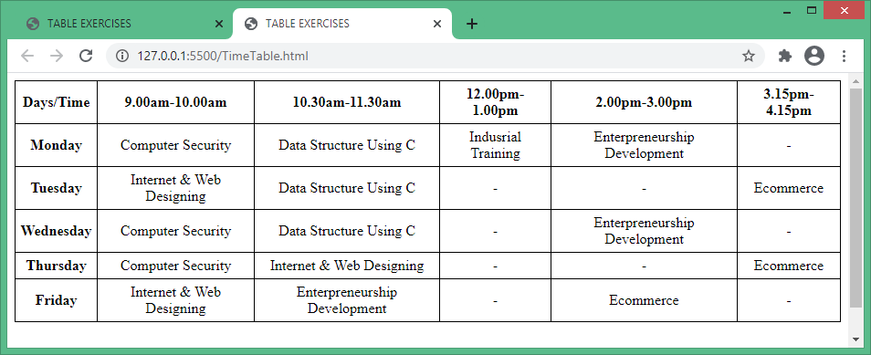 <td>-</td>

</tr>

<tr>

<th>Tuesday</th>

<td>Internet & Web Designing</td>

<td>Data Structure Using C</td>

<td>-</td>

<td>-</td>

<td>Ecommerce</td>

</tr>

<tr>